Virtual Box Lab Setup

Introduction

Before the beginning of the practical labs there needs to be a segmented network to simulate internal & external traffic. Use of VirtualBox’s NAT Networks will be used to simulate this segmented network.

**Virtual Box Download Link:**

<https://www.virtualbox.org/wiki/Downloads>

*Download the installer package for your OS version*

**Submission:** You need to submit a detailed lab report, with screenshots, to describe what you have done and observed. Questions will be defined as you progress through the lab. The lab report will be compiled as a Word document and submitted on Brightspace by **MONTH DAY at TIME AM/PM.**

Creating NAT Networks

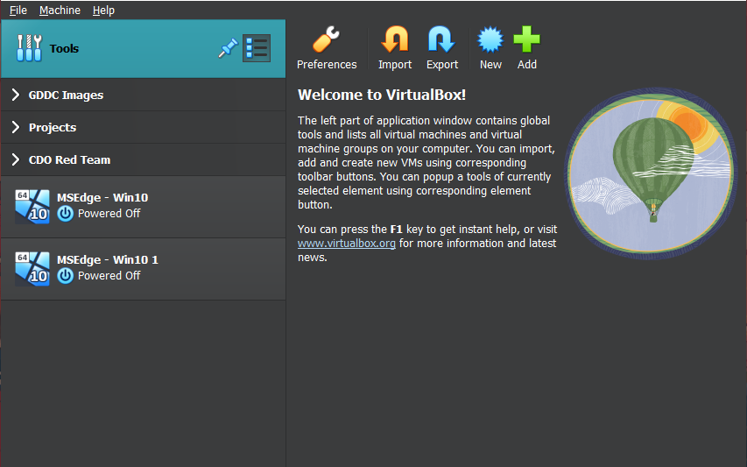

Once in Virtual Box, Right Click the “**Tools**” bar in the top left corner. In the “**Tools**” dropdown menu select “**Network Manager**”

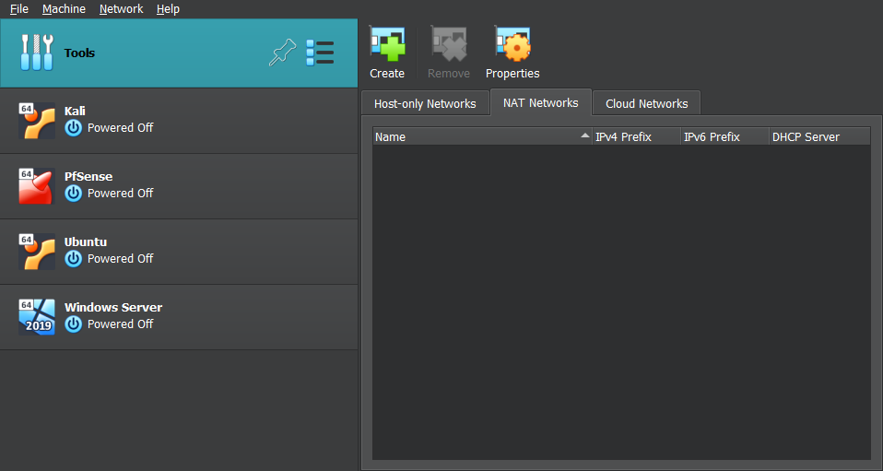Once in the **Network Manager menu**, select the **NAT Network** tab.

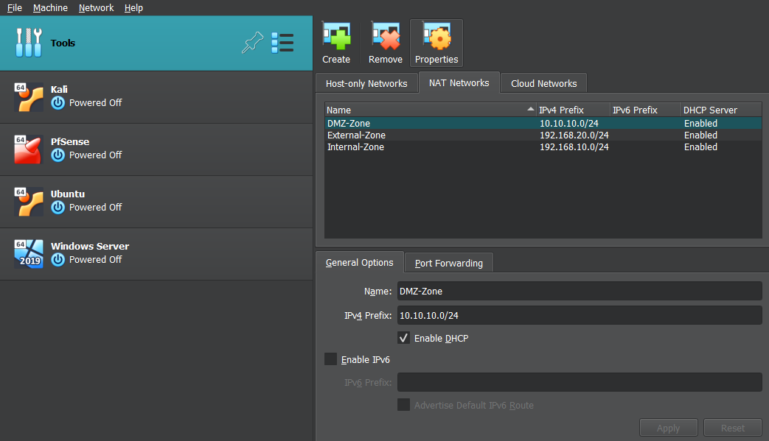Create a new NAT Network by clicking **Create**, once the NAT Network is created **Name the zones after the following:**

Internal-Zone: 192.168.10.0/24

External-Zone: 192.168.20.0/24

DMZ: 10.10.10.0/24

Once these are created, they are ready to be used in Virtual Machines.

Joining VM to NAT Network

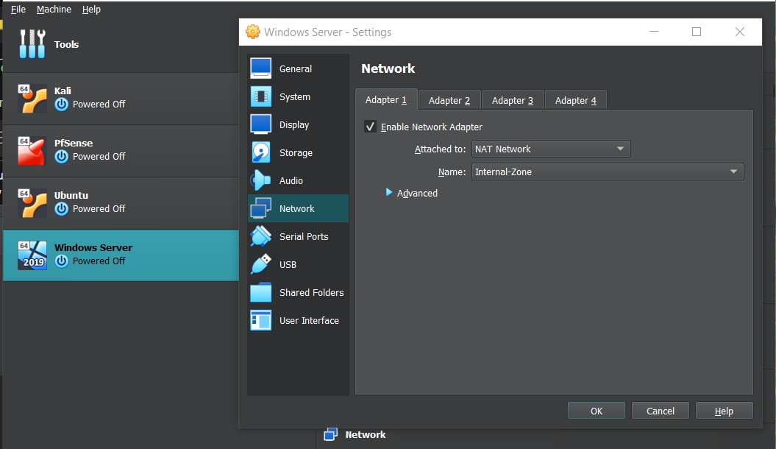

In the **Virtual Machine Settings**, select **Network** and changed the “**Attached to:**” to the **NAT Network** needed.